**CIS444 PROJECT PROPOSAL:**

**CSUSM STUDENT FAQ FORUM**

**[Project Authors]**

**Emily Arango, Kenneth Ha, Hunter Nitta-Hill, Nicholas Sotto, Kane Svelan**

FAQ/Forum

* campus wide and separated into different majors
* have each one have different discussion forums
* Students may discuss studies, recommend classes, general discussions, concerns, any form of talking
* Blue and white school colors
* Undecided majors can ask major-related questions in forums
* Option to be anonymous but still need authentication to use
* Public discussion first then makes Direct message function if have time
* Potential risk: Lack of faculty oversight can lead to unregulated comments
* Leaning towards student run website
* Have disclaimer after fist join
* Have description on account: their major and year but can still be anonymous

Goal: General safe space discussion for Students

1. **Describe the real-life problem to be solved with a Web server.**

Currently, there exists no official CSUSM discussion forum that encompasses multiple topics for the offered majors. This system would allow users to filter through forum threads to connect with other students with similar majors, career paths, and ideas.

Allows accessibility for discussion and communication amongst students of different majors and gives students convivence of asking for advice within one's own major or another.

1. **Identify all the potential users of such a website (ideally, you would have already interviewed some potential users at this stage).**

This system is primarily geared towards CSUSM Students. More specifically, new/undeclared students who want to learn more about the major/classes they are interested in. The system will also appeal to students who are not new and are trying to figure out which classes to enroll in. CSUSM faculty and other non-students may only view the forum but will be unable to create posts or comment on existing posts.

Aside from new and currently enrolled students, this system will also be monitored and maintained by CSUSM IT admins regularly.

1. **Include how many Web pages are potentially needed and what each page is exactly supposed to work, but not the actual implemented pages, and their wireframes.**

The system will have 4 main pages:

1. Homepage / Major Catalog
   1. Displays all CSUSM majors and links to their thread boards
   2. Includes links to respective academic department pages
2. Major Specific Board
   1. Allows users to view previews of created posts by forum users
   2. Search and filter function for specific thread information
   3. Navigation buttons to view next/previous pages
3. Thread
   1. Allows users to view full posts
   2. Comment section for replying to the original poster (OP)
4. Create Post
   1. Users must fill in a post title, post body, and select a post tag, and submit
   2. Users can edit their post body with features such as text alignment, font adjustments, ordered/unordered lists, etc.

*Function / Page priority scale (1: highest – 3: lowest)

|  |  |
| --- | --- |
| **Function / Page** | **Priority** |
| Log-In Page | 3 |
| Profile Page | 3 |
| Home Page | 1 |
| Major Catalog | 1 |
| Major Forum Board | 1 |
| View Post/Comment | 1 |
| Create Post | 1 |

1. **Indicate what users are expected to enter and receive for each page.**

login into their csusm account to verify they are a student. Should have a nice welcome page and different links/pages they can click on for further details on certain forums

- Sign In Page: User can sign in and is redirected to list of forums once signed in.

- List of Forums: Discussion Forums organized in alphabetical order based on department. After selecting discussion forum, redirected to threads for that forum. Filter potentially can change the way that the discussion forums are organized.

- Threads: List of threads for a given forum organized based on last replied to date by default. Filter can potentially change the way that the threads are sorted and also can filter based on tags. Can choose to make a new thread or view a preexisting thread and is then redirected to either depending on which is chosen.

- Make a Post: Create new thread. Can add tags related to class/topic.

- View Thread: See list of all replies to thread.

- Reply to Thread: User can reply to thread or choose to cancel their input.

1. **Illustrate how each potential user is going to interact with your Web site.**

First user will see the login page where they log in using their school email and password,

Then the user will be able to see the categories of majors

Once the user click on the major(category) they will be able to see the threads which are created by the user about that major, and there will be tags on specific classes and topics

Profile settings, will be able to change profile pic, checkbox for anonymous or non anonymous. Also include checkbox option to display major in profile. If the user decides to display major, they can select their major from a drop-down list which will display the departments and subsequently select another drop-down sub-list for their major.

1. **Draw a diagram indicating the interactions among the Web pages, i.e., when a button or link is clicked on a page, which another page is to be loaded up to the user.**

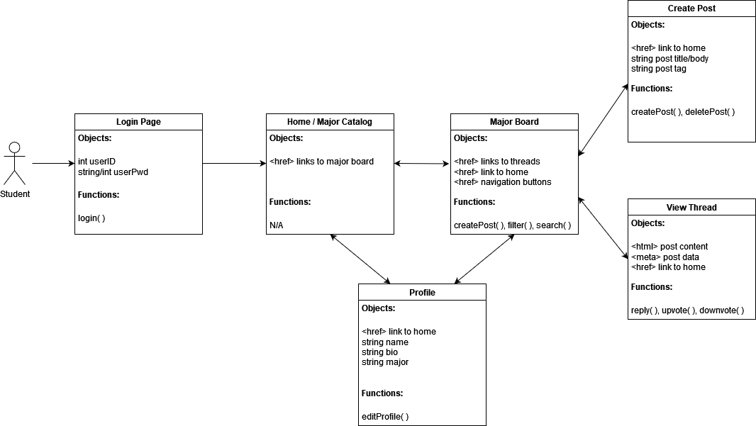

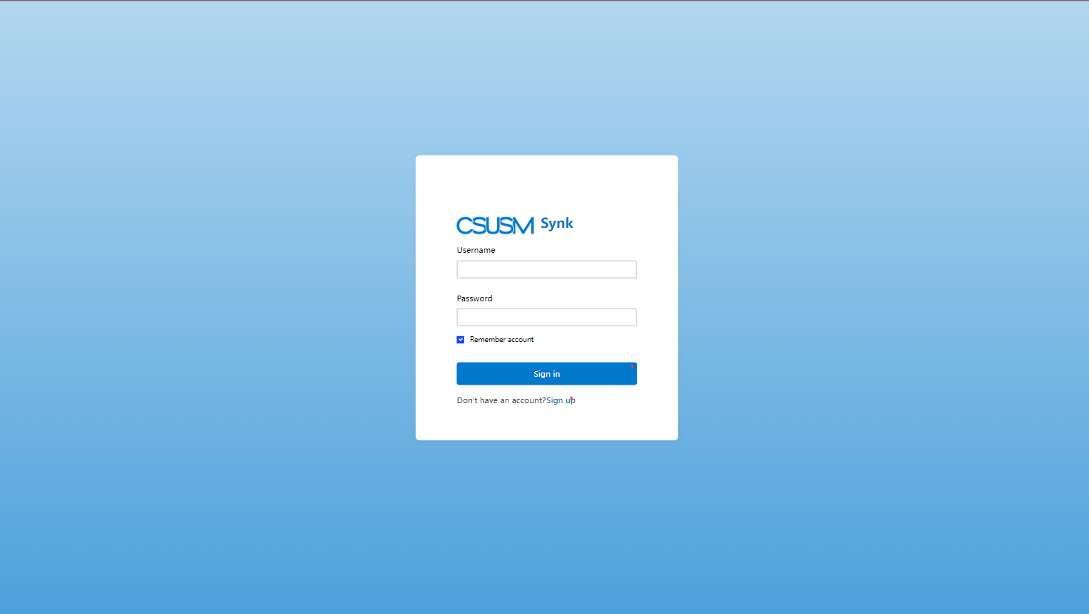

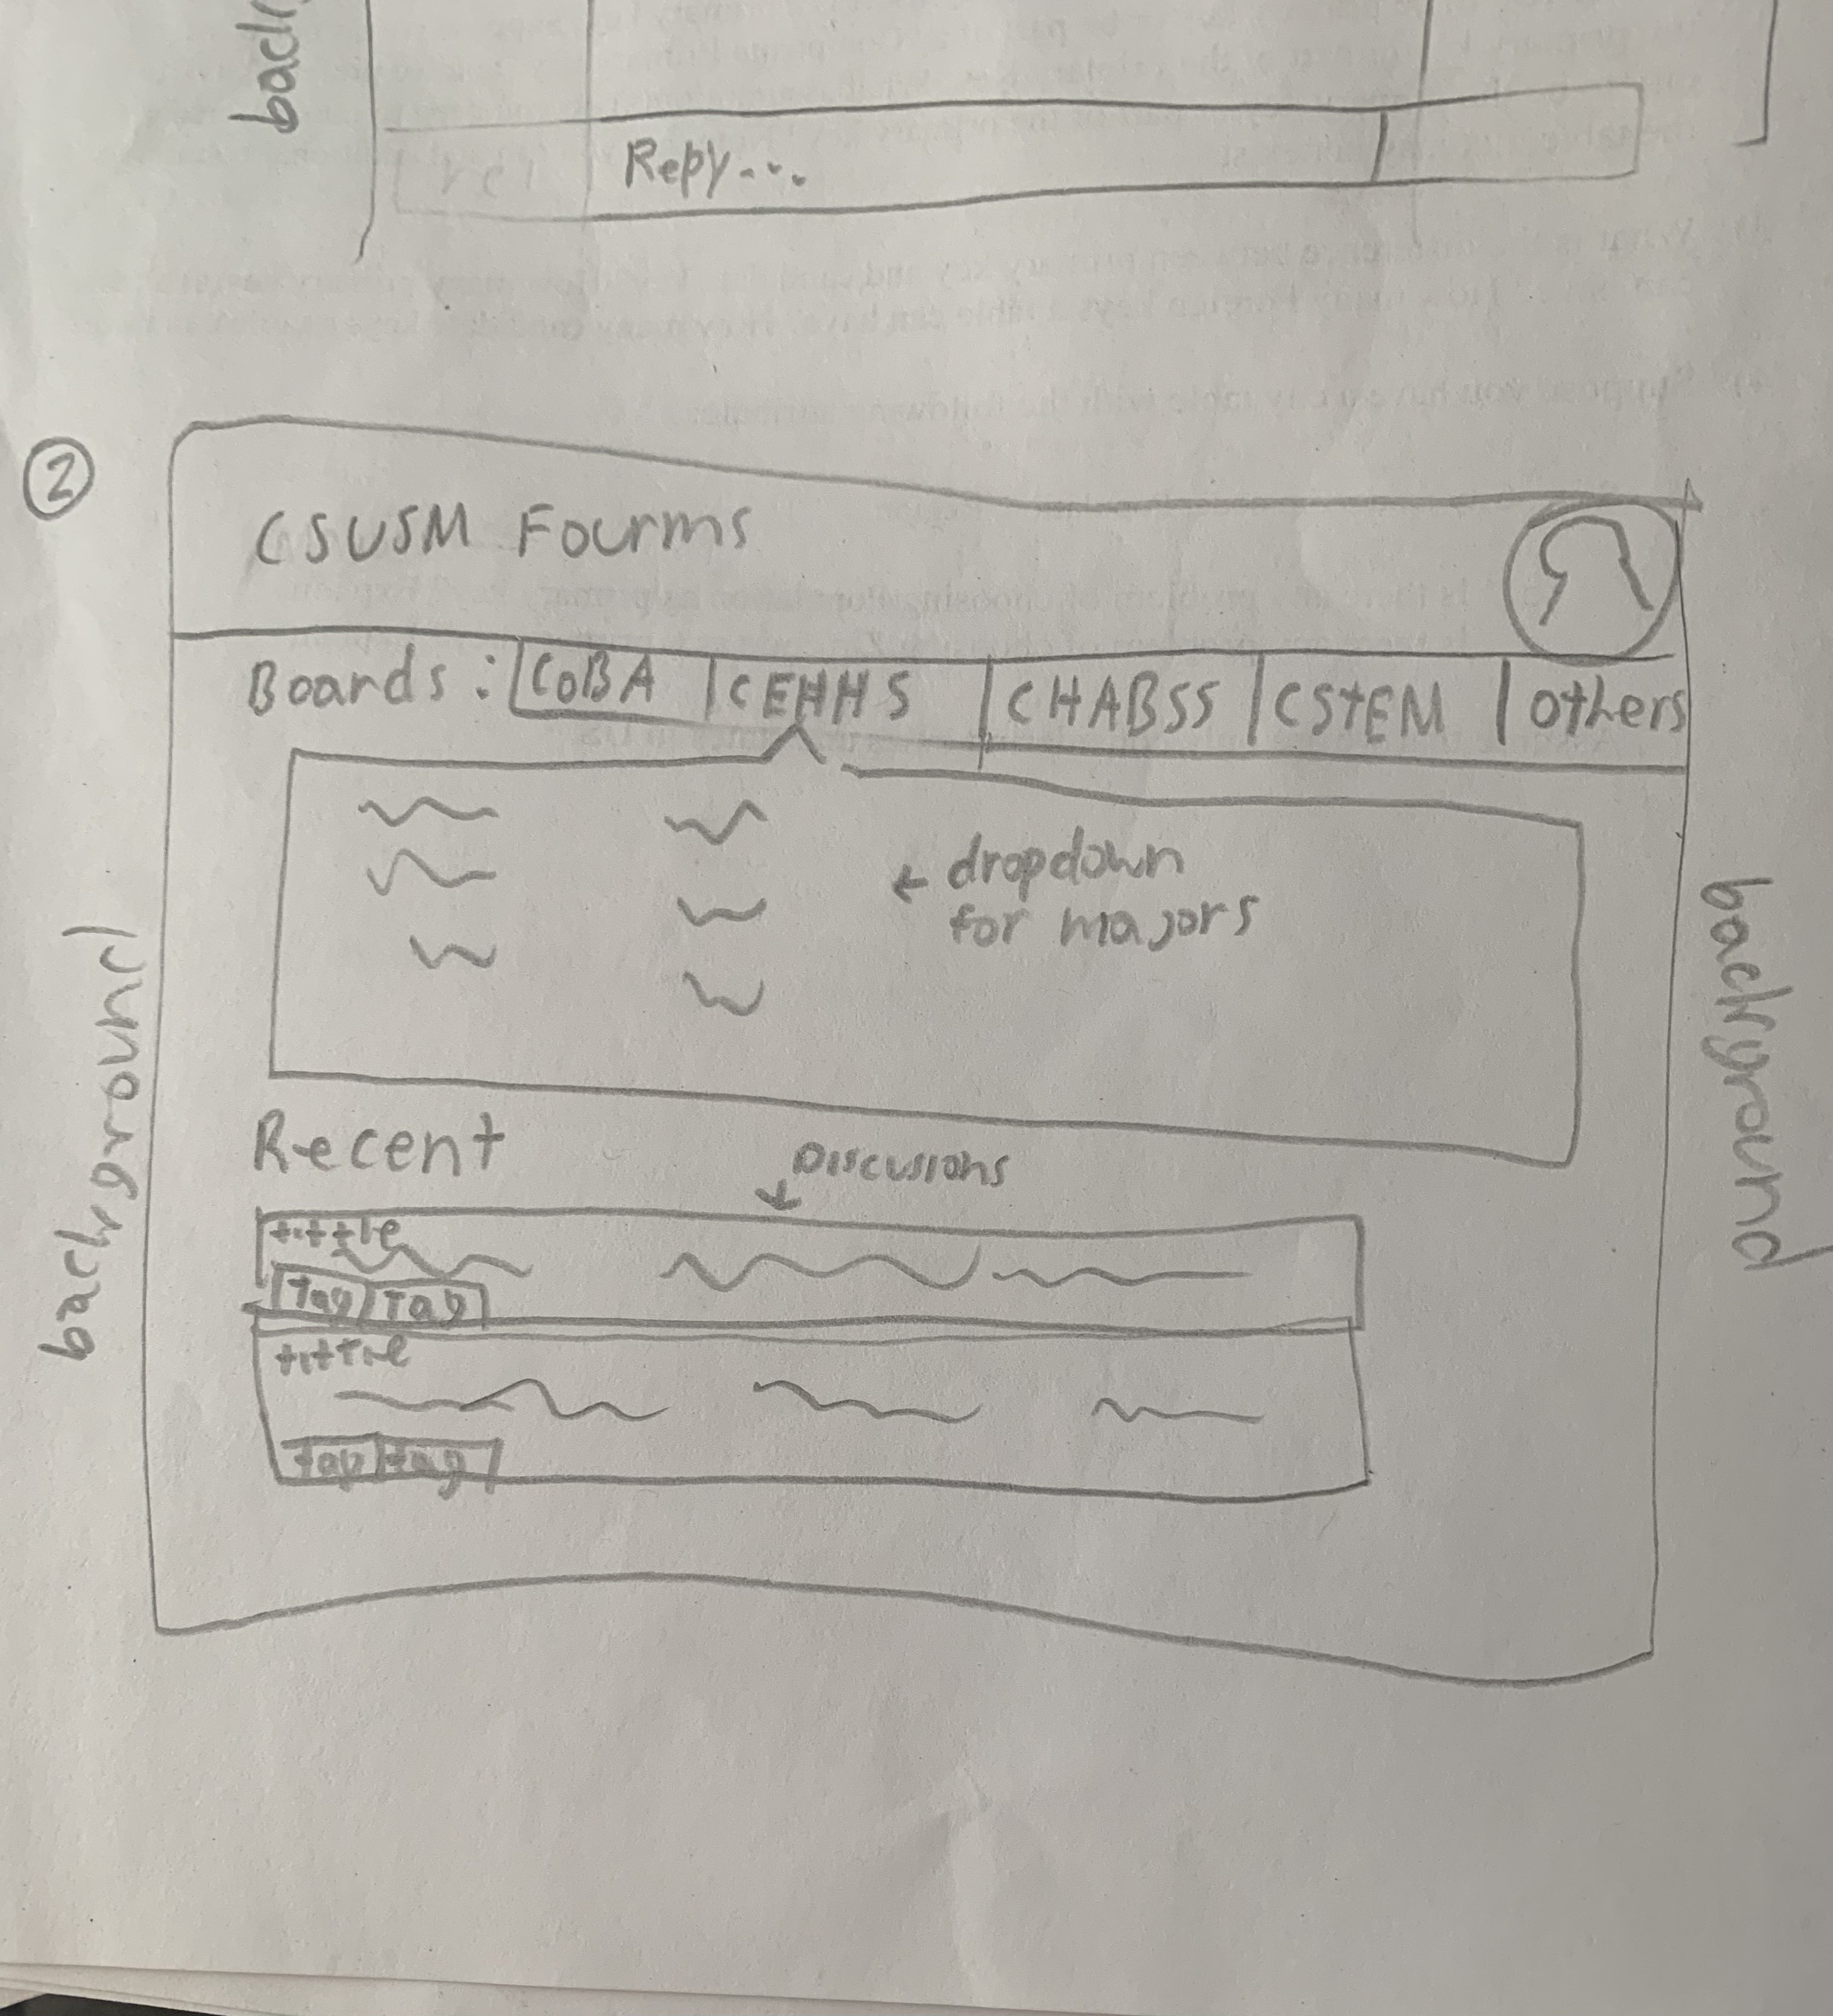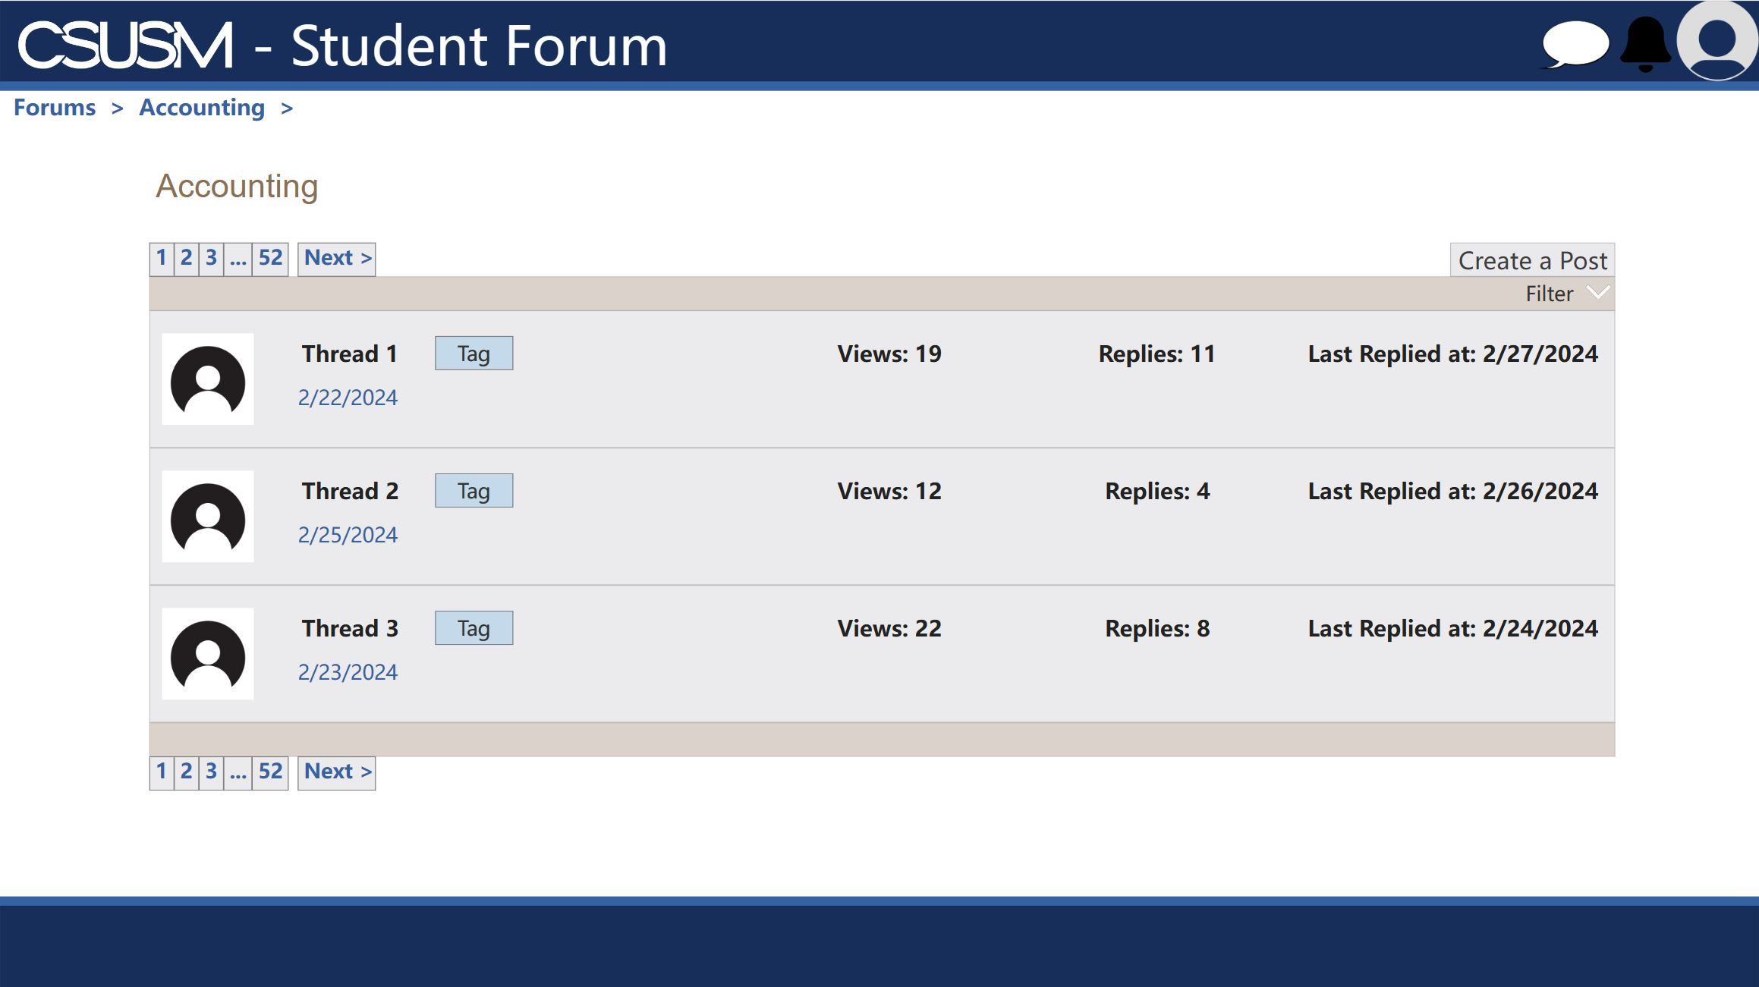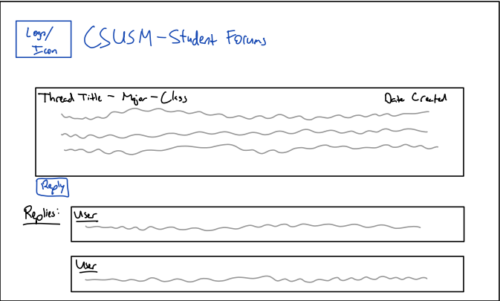

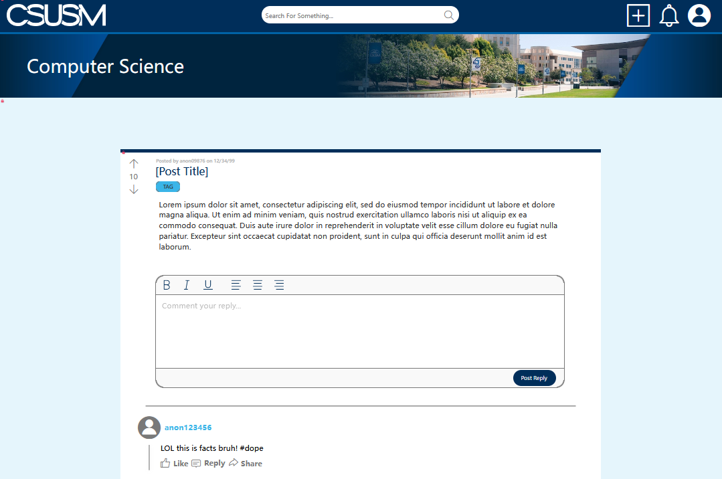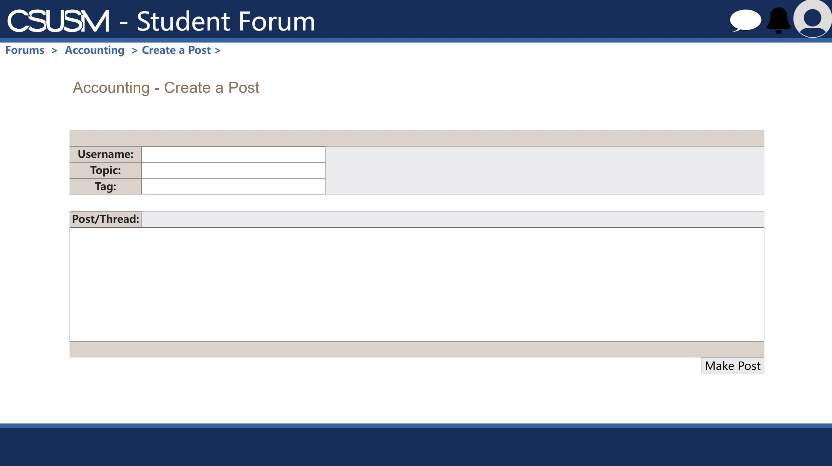

Goals for project(must get each part done before moving to next)

1.set up for newer students for general info about each major

2. set up discussion for classes within each major (able to create forms and add tags)

3. non academic discussion and add filters